HOLIDAY GREETINGS

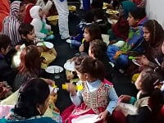
I hope all of you enjoyed a blessed Thanksgiving and a Christ centered Christmas and are experiencing a blessed new year. Our Christmas was blessed with family and friends. I often think how blessed we are in this great nation with such abundance and most of the world suffers the lack of basic needs. Christmas eve was spent with Simone’s family and Christmas day with mine. What a sweet time we had. We had a candlelight service at Simone’s church. It was a sweet and sacred time.
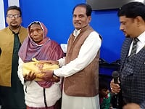
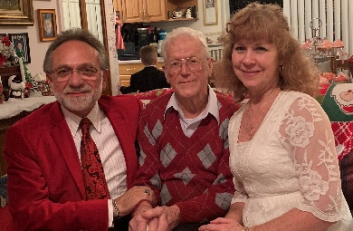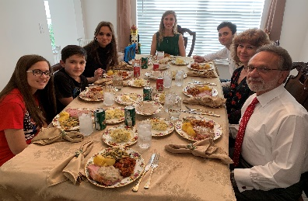
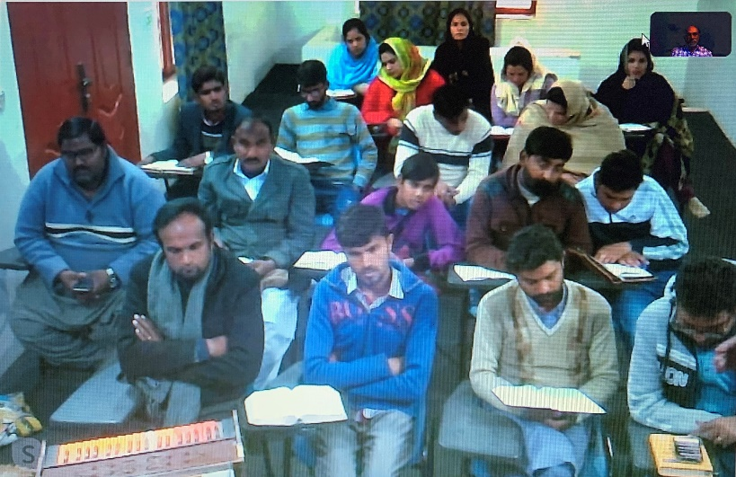
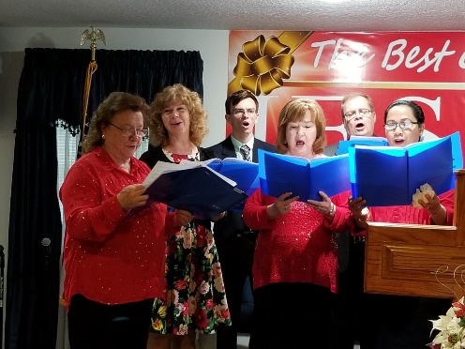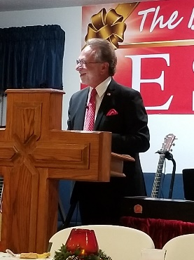

A BLESSED 2019

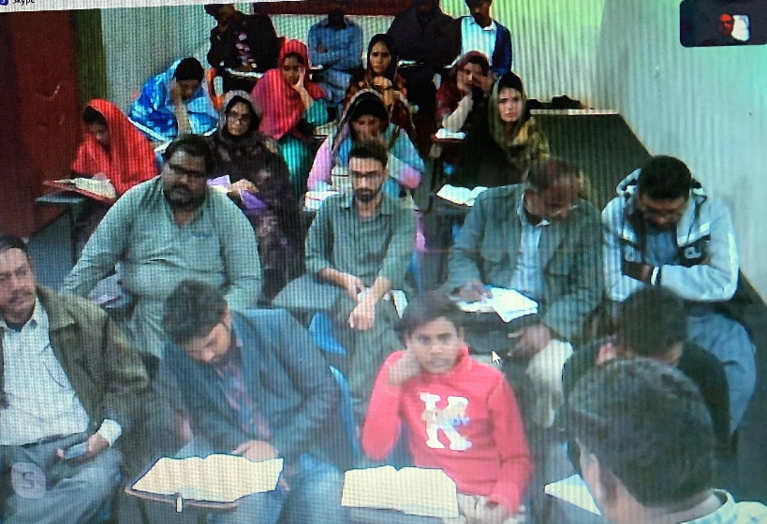
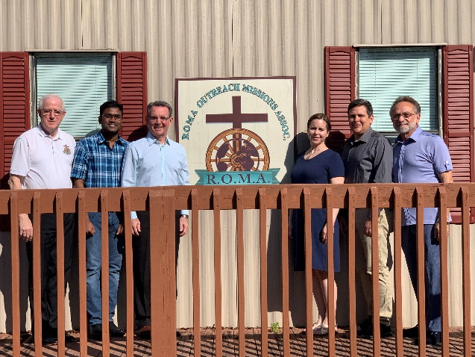
God really blessed this past year in all of our many ministries. Not to say we haven’t had our share of struggles. But God is always faithful! The ROMA missionary family has doubled this year and we have already had 1 of 2 candidate’s trainings this year. Please pray for Rob and Anna Wray and Sam Amarlapudi.

The St. Petersburg Roma ministry has been blessed beyond measure by God. Though we have room to grow and reach more Roma in the area. Our faithful core are growing spiritually by leaps and bounds.
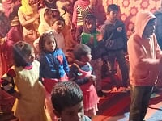
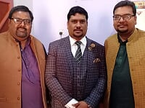
I will let these pictures speak for themselves concerning our Pakistan Roma Ministry. You know what they say; “A picture is worth a thousand words”.
LOOKING FORWARD TO A BLESSED 2020

This year holds more opportunities then I can handle. I find myself turning down invitations to preach, hold conferences and visit foreign fields.

We are allowing the laity in St. Petersburg to be more active in pulpit ministry. Raymond Mitchell is doing a great job and someday will be a great preacher.
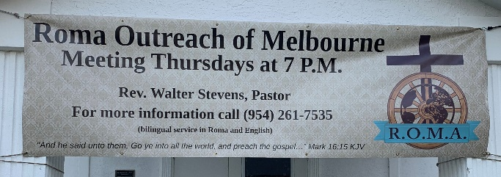
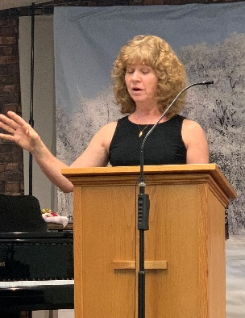
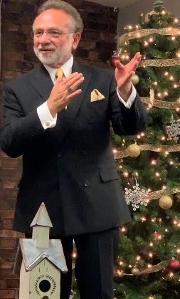
Since my marriage to Simone, I have moved into her home in Palm Bay. I still have an office in Bradenton because of R.O.M.A. being a part of Bible Baptist church there. I commute there a few times per week but am also establishing an office here in Palm Bay. My contact information will not change.

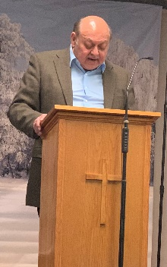
At the end of 2019 I filled the pulpit for Missionary Lawrence Evans at his Roma ministry in Hollywood, FL. Simone sang, and I preached. Bro. Evans is without a music program and Simone offered her expertise in the area of sacred music. Simone and I are now going to Bro. Evans 1 Sunday per month to help with his music program. Of course, I get to preach when I am there.

PRAISES

We were able to send over 600 lbs. of clothes, toys and other items to Romania and Hungary. We were also able to send over $6,000 to Romania, Hungary and Pakistan to purchase food for all the Roma families in our churches this holiday season.

PRAYER REQUESTS

- Please be in prayer for the finances of the home office of our new mission board, R.O.M.A. We are currently running a deficit almost every month.
- Pray for the R.O.M.A. family of missionaries
- Pray for our new ministry in Melbourne
- Pray for my Spring schedule of meetings and trips abroad.
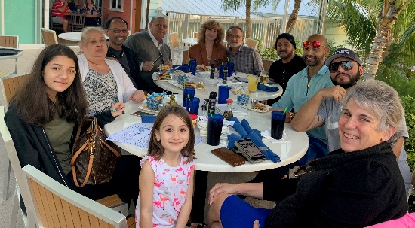
By the time you receive this report we would have already started a new ministry to the Roma here in Melbourne. We are meeting every Thursday night. Please keep this new station of service in your prayers. I will keep you updated in my next report.

TRAVEL IN MINISTRY

January 27-31 will find me in Honduras, where I will be sharing the pulpit with Pastor Sal Yannizzi and others. We are preaching a conference to about 250 national pastors. These preachers need to be encouraged and challenged. I will be preaching 3 times. One of those times will be an evening revival service to pastors and their congregations.

Of course, springtime is missions conference time. I am scheduled in several conferences in OH, KY, IN and elsewhere.

April 16-28 I will be in Hungary, Romania and Bulgaria. Easter in Romania is 4/19 this year. I am taking a few with me on his trip who are interested in foreign missions. We will be there to encourage the pastors and churches.

June 3-7 I will be preaching at Mission Bible church in Halifax, NS Canada. I have preached this conference annually for the past several years

OUR PRAYER LETTER

Our prayer letter and report are sent out quarterly. We send out a Fall/ Winter around the second week of January, A Winter/Spring around the second week of April a Spring/summer around the second week of July and a Summer/fall report around the second week of October. We send them out by regular post and email via MailChimp. If you have not been receiving our report either way, please let me know. Also signify your preference, either regular post, email or both. If you prefer email, please include an email address in your correspondence. Please keep in mind that I post on social media very often of what is going on in our ministries. You call follow us on Facebook at Walter N Simone Stevens or at Instagram at gypsypreacher.

