DOLLY’S PROGRESS

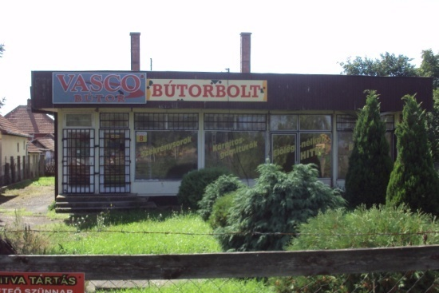
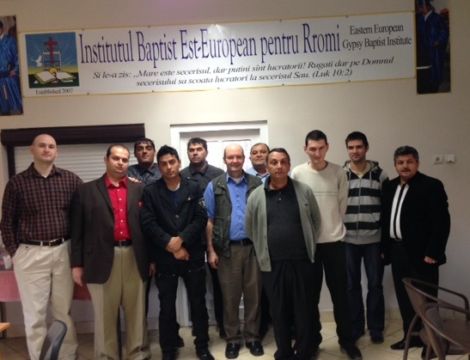
On February 18, Dolly finished her fifth chemo treatment. She has one more to go on March 11. She will undergo a CT scan on March 22 and see her doctor on March 25 to determine how the tumors have responded to the treatments. We have return airline tickets for Hungary on April 1. Please pray that we will hear good news and that Dolly will have the stamina to travel the long flights home.

ANNOUNCING THE BIRTH OF JOEL REAGAN STEVENS
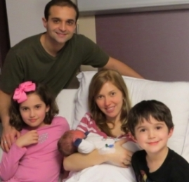
Joel
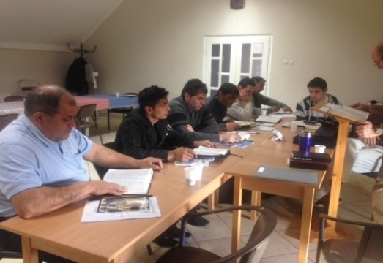
Reagan Stevens was born on February 19, 2014, at 8:57AM. He weighed 7 lbs. and 4 oz. and was 19.3 inches long. He is our 9th grandchild and Mike and Sarah’s 3rd child, We are praising the Lord that Sarah’s mother was able to go over to Bucharest and help watch our other 2 grandchildren. She landed the night before the baby was born. Isn’t God good? Mama and baby are now home doing well.

GYPSY BAPTIST INSTITUTE

The Lord really blessed our institute, with a good group of students and blessed teachers. We thank the Lord for Jim Pranger who came from Budapest to teach and for Mirci Pricop who has become a real blessing to the students. Also for Pastor Fekete and our precious sisters who do the cooking and cleaning.

BUSY MEETING SCHEDULE

March 2nd Two churches in WV
March 5th Xenia, OH
March 6th Miami University, Ohio
March 8-11 Connersville, IN
March 12-16 Huber Hts. OH
March 19-23, Troy, OH
March 26th, Port Huron, MI
March 30th Mansfield & Ravenna, OH
PLEASE PRAY FOR THESE MEETINGS!

FUNDS SUPPLIED FOR BUILDING REPAIRS

We are so thankful that God has supplied 2 large donations for the building repair and renovation in Biharkeresztes, Hungary. $10,000 came in from our home church in Cleveland out of their Missionary Christmas offering. The other came from Word of Life of Hungary as Pail presented the need to his alma mater. They have committed to $5,000. Thank you, Jesus!
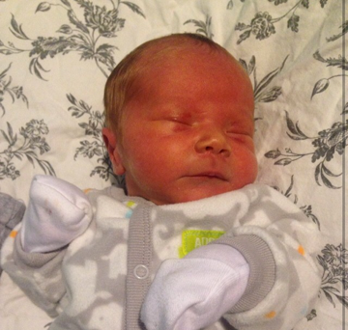
HUMANITARIAN AID SHIPPED TO ROMANIA
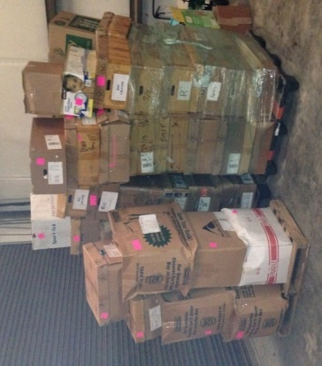
This month we were able to ship 1,500 lbs of school uniforms to our churches in Romania. We are hoping that now we will be able to send some of these children to school. Our thanks to Bro. Mickey Johnson and others who helped make this project happen.

